Please return latest by 01.04.2020 to
E-mail: plaukimo.federacija@gmail.com
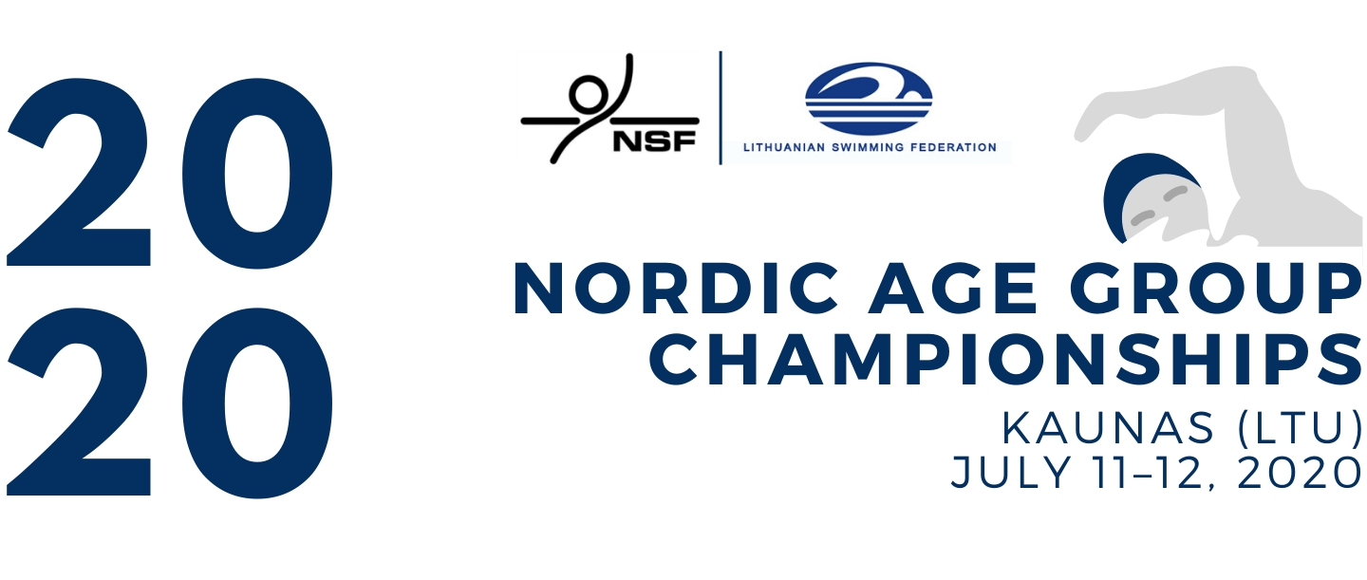Preliminary
ACCOMMODATION FORM
Country: | Click or tap here to enter text. | Country code: | Click or tap here to enter text.
Email address: | Click or tap here to enter text.
Phone no: | Click or tap here to enter text.
Contact person: | Click or tap here to enter text. | Function: | Click or tap here to enter text.

Hotel choice No 1: | Choose an item. | No 2: | Choose an item.
Hotel accommodation is subject to availability and will be allocated on a first come, first served basis.
Arrival date: | Click or tap to enter a date. | Departure date: | Click or tap to enter a date.

The preferable time for training section (July 10th): | Click or tap here to enter text.

 | B&B | Full board
Single rooms | Click or tap here to enter text. | Click or tap here to enter text.
Twin rooms | Click or tap here to enter text. | Click or tap here to enter text.
Triple rooms (if applicable) | Click or tap here to enter text. | Click or tap here to enter text.
Federation stamp (if available)
Date: | Click or tap to enter a date. | Signature:
 |  |  | President/General Secretary

